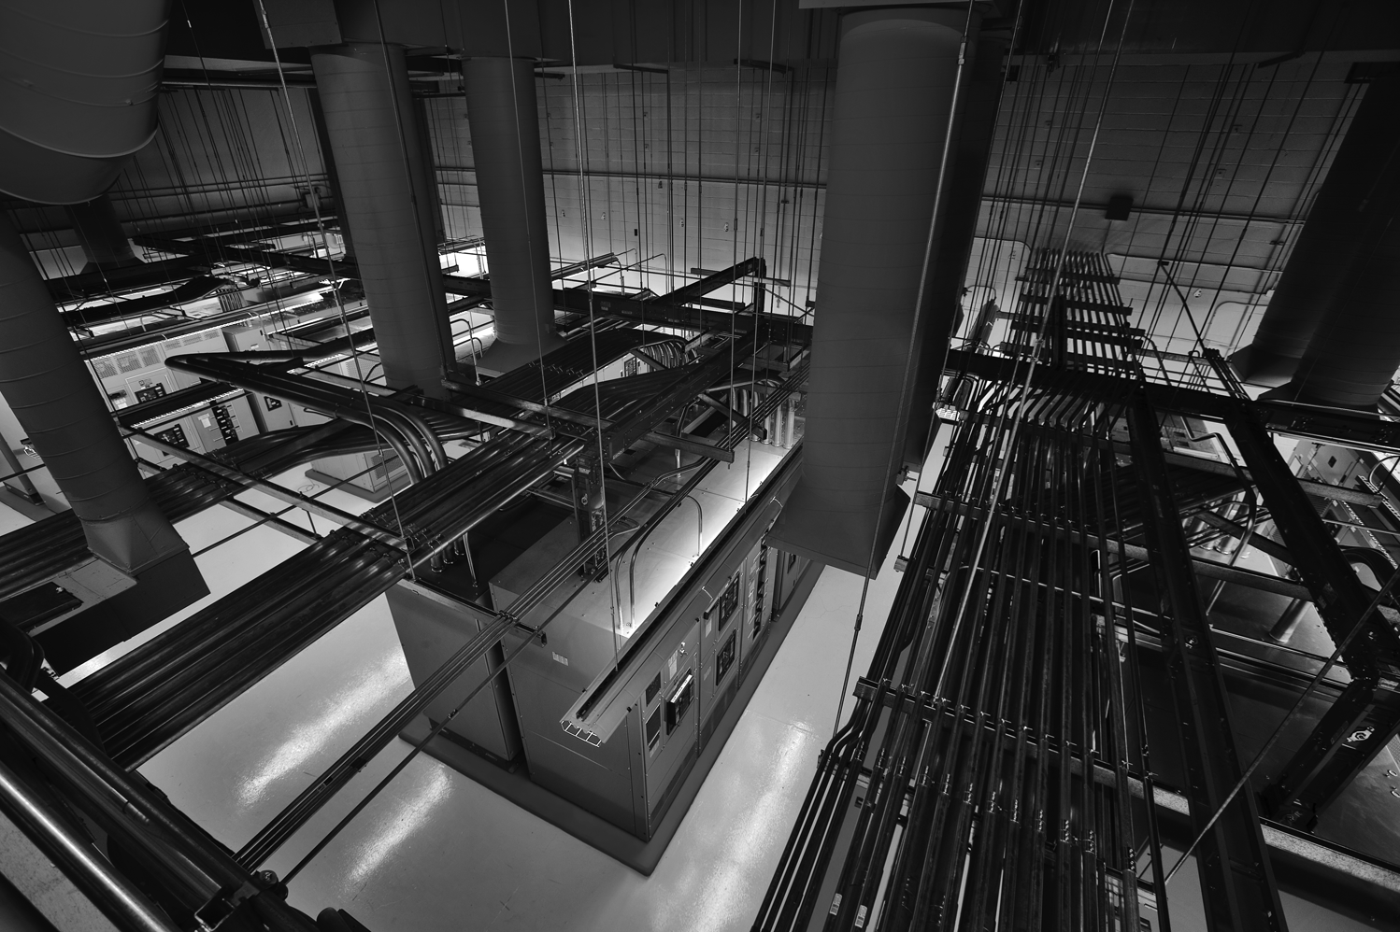

service Delivery REport

STATE STREET ASIA LIMITED HK2

Period: January 2020

The ideas set forth in this Project Description and attached materials are the sole property of Equinix, Inc. (“Equinix”) and its contributing Partners. Nothing contained herein is to be disseminated, distributed or otherwise conveyed to a third party without the express permission of Equinix. In turn, Equinix agrees to mutually respect all information submitted or supplied by STATE STREET ASIA LIMITED.

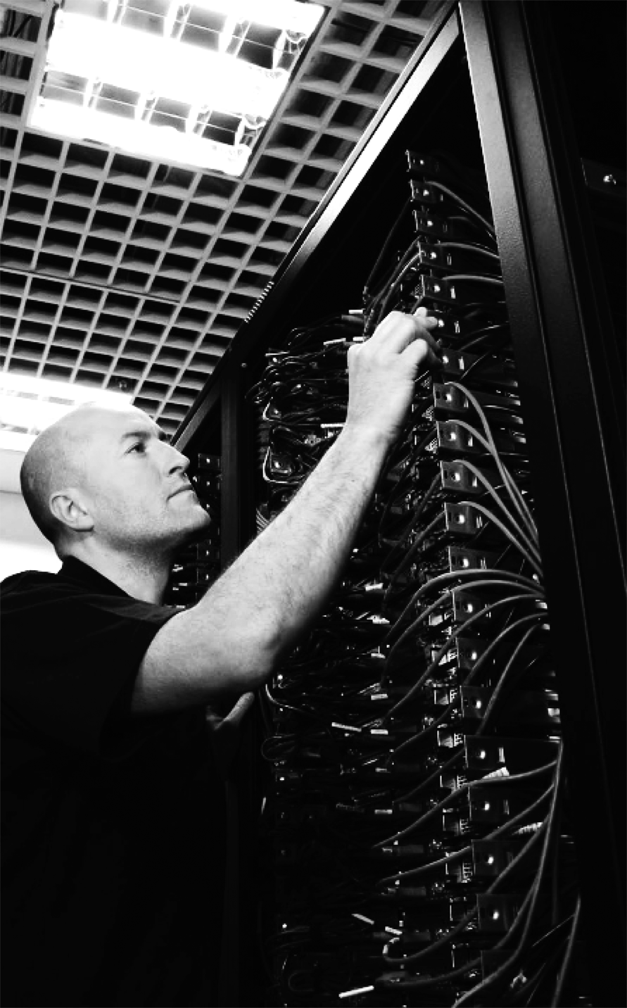

# :Source:imgs:cht_120308_nrsmm108_LR.tif

Table of contents

EXECUTIVE SUMMARY 4

Temperature & relative humidity 5

INCIDENT REPORT SUMMARY 6

Security 6

Site Security Incidents 6

Access log 6

Maintenance 7

Scheduled Maintenance 7

Current power Draw 8

Existing Portal list 8

# 

# :Source:imgs:cht_120308_nrsmm108_LR.tifEXECUTIVE SUMMARY

During the month, the SLA for all facility services for HK2 remained at 100%.

|  |  |
| --- | --- |
| Facility Service | Available SLA |
| Power | 100% |
| Temperature | 100% |
| Relative Humidity | 100% |

There were no incidents reported for the month.

|  |  |
| --- | --- |
| Prepared By | Ken Tang, Equinix IBX HK2 |
| Prepared For | STATE STREET ASIA LIMITED HK2 |
| Important Note | Equinix Proprietary Information: The information contained in this document is confidential and proprietary to Equinix. The use, disclosure, reproduction, or distribution of this information to any third party without the written permission of Equinix is prohibited. |

# Temperature & relative humidity

**The temperature remained within the control range for the month. (SLA: 18ºC - 27ºC)**

**The relative humidity remained within range for the month. (SLA: 25% - 65%)**



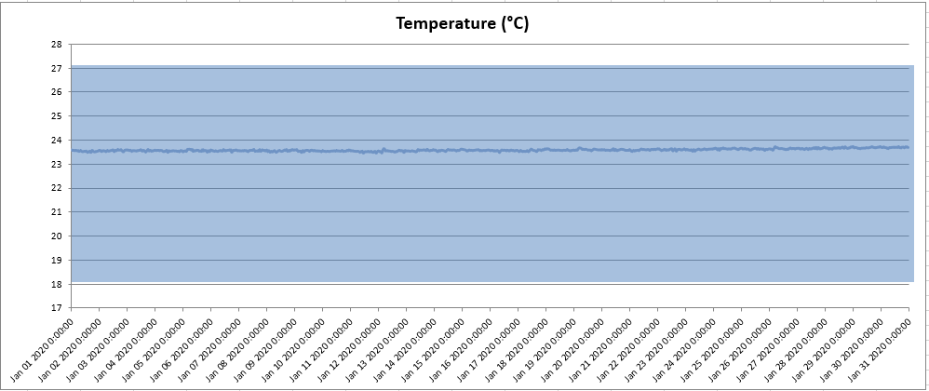

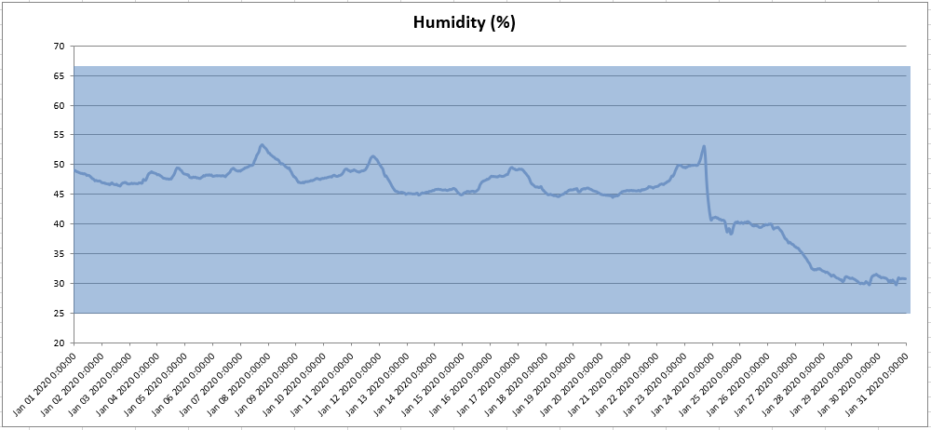

# INCIDENT REPORT SUMMARY

The incident report summary will comprise details of incidents occurred within the reporting month that affects the performance of the Power, Temperature and Relative Humidity to the STATE STREET ASIA LIMITED area.

Below is a summary of the incident report for the month.

|  |  |  |  |  |  |
| --- | --- | --- | --- | --- | --- |
| **S/No** | **Incident**  **Ticket no.** | **Incident**  **Details** | **Start Date/Time**  **of Occurrence** | **Start Date/Time**  **of Resolution** | **Comments** |
| 1 | NIL |  |  |  |  |

# 

# Security

## Site Security Incidents

|  |  |
| --- | --- |
| **Date** | **Incident Details** |
|  | NIL |

## Access log



# Maintenance

## Scheduled Maintenance

|  |  |  |  |
| --- | --- | --- | --- |
| Facility Preventative Maintenance Schedule of HK2 16/F | | | |
|  | 2020 | | |
| **System** | Jan | Feb | Mar |
| Chiller Units | 13-14 | 6-7 | 5-6 |
| Chiller PLC |  | 19 |  |
| Mechanical Services (FCU, EAF, PAU & Water detection sensor etc.), Plumbing | 13-18 |  | 26(Vent.) |
| Water Leakage Detection | 15-17 | 18-21 | 18-20,23 |
| Cooling Tower System | 15-17 | 18-21 | 18-20,23 |
| Chemical Treatment | 2-3,8 | 10,28 | 10,31 |
| CRAC Units | 20-24 |  |  |
| iCOMS | 21-24 |  |  |
| XD Systems |  |  |  |
| BMS and Access Control |  | 13-14 (Part 1) |  |
| Fire Services | 15-19 |  |  |
| UPS |  |  |  |
| STS |  |  |  |
| PDU |  |  |  |
| Battery Monitoring System |  |  |  |
| LV System | 15-17 'P. Bar |  |  |
| HV System |  |  | 15-16 21-22 |
| Generator Sets , Fuel Tank and Fuel Supply System | 20-22 | 17-19 | 4-6 (No 15/F genset mains allowed) 15-16, 21 |
| Security Systems |  | 3-7 |  |
| CCTV maintenance |  | 10-14 |  |
| PQM (Annual) | 22-24 |  |  |
| Pull the Plug Test (Ph.2 & Ph.3) |  |  |  |
| HV WR2 (Phase 2 & 3) |  |  |  |
| Lighting check and temperature & RH sensor inspection and power circuit label visual checking |  |  |  |

# Current power Draw



# Existing Portal list

|  |  |  |  |  |
| --- | --- | --- | --- | --- |
| **Username:** | **First Name:** | **Last Name:** | **Email:** | **Work Phone:** |
| alexyuen | Alex | Yuen | alex.t.yuen@statestreet.com | +85228405341 |
| alfredman | Alfred | Man | alfred.man@statestreet.com | +85228405323 |
| andrew.wong@statestreet.com | Andrew | Wong | Andrew.Wong@statestreet.com | 98600222 |
| awong7@statestreet.com | Andy | Wong | awong7@statestreet.com | 28405443 |
| awong8 | Amy | Wong | wongaoy@hk1.ibm.com | 28257202 |
| chanlaisun | Lai Sun | Chan | Lai-Sun.Chan@statestreet.com | 36677042 |
| chau@ap.equinix.com3 | Clare | Hau | chau@ap.equinix.com | 29707847 |
| chi.kin.chiu@statestreet.com | Chi Kin | Chiu | Chi.kin.chiu@statestreet.com | 98521811 |
| cliu@statestreet.com | David | Liu | cliu@StateStreet.com | 31531022 |
| dho2@statestreet.com | Danny | Ho | DHo2@statestreet.com | 28405363 |
| fred.yau@hk.verizon.com | Fred | Yau | fred.yau@hk.verizon.com | 2233 6339 |
| hkchan@statestreet.com | Hector | Chan | hkchan@statestreet.com | 29789232 |
| ivan.tam@statestreet.com | Ivan | Tam | ivan.tam@statestreet.com | 28405378 |
| jerrychong | Jerry | Chong | jerry.chong@statestreet.com | +85222301600 |
| jtcheng@statestreet.com | John | Cheng | JTCheng@statestreet.com | 29789255 |
| jtcheng@statestreet.com1 | John | Cheng | JTCheng@statestreet.com | 63970754 |
| keith.li@statestreet.com | Keith | Li | keith.li@statestreet.com | 31531065 |
| kin.cheung@statestreet.com | Kim | Cheung | kin.cheung@statestreet.com | 28405388 |
| mlee5@statestreet.com | Michael | Lee | MLee5@statestreet.com | 36677102 |
| nelson.ng@statestreet.com | Nelson | Ng | Nelson.Ng@statestreet.com | 28405388 |
| rwan@statestreet.com | Ray | Wan | RWan@statestreet.com | 92340023 |
| samwong | Sam | Wong | smwong@statestreet.com | +85228405493 |
| scott.lee@statestreet.com | Scott | Lee | Scott.Lee@statestreet.com | 92339414 |
| simonto | Simon Luen Ki | To | simon.to@statestreet.com | 97266368 |
| sunny.chan | Sunny | Chan | sunny.chan@statestreet.com | 21030205 |
| sunny.wong@statestreet.com | Sunny | Wong | sunny.wong@statestreet.com | 22301632 |
| titan.siu@statestreet.com | Titan | Siu | titan.siu@statestreet.com | 36677128 |
| victor.lim@hk.verizon.com | Victor | Lim | victor.lim@hk.verizon.com | 91503018 |
| victorlau | Victor | Lau | Vlau@statestreet.com | +85229789290 |
| wleung@statestreet.com | William | Leung | wleung@statestreet.com | 28405348 |